|  |
| --- |
| **Ciara Sastre-DT282/1-C15355361** |
| Software for the Global Market Assignment. |
|  |
| Student ID: C15355361 |
|  |
| **Ciara Sastre** |
| **4/14/2016** |
|  |

## Table of Contents

Introduction……….…………………………………………………………………………………………………………………………3

User Research and Modeling……………………………………………………………………………………………………………5

Envisioning, Prototyping, Evaluation…………………………………………………………………………………………………10

Implementaion …………..…………………………………………………………………………………………………………………18

Conclusion……….……………………………………………………………………………………………………………………………20

Introduction

## Introduction:

As part of my assignment for Software for the Global Market I am to interview 5 people and gather

A primary and secondary persona from them.

From the interviews I am to conclude a problem that the users are having and develop a website

Domain with the idea of resolving this problem.

I am then to use Cookies, XML, DOM/Javascript and html canvas in order to create a very interactive

User friendly website.

## My Idea:

My idea for this website is to create a domain where everyone can come together to share their stories

And create their own books. I want more people to get involved in creative writing and find other people

With the same interests as them.

User Research and Modelling

## User Research and Modelling

As part of my research I conducted an interview with five people with

The following questions:

**Interview**

1) When was the last time you wrote a short story or had an idea for one?

2) What is your favourite book/Genre?

3) Would you have ever thought about becoming an author why/when?

4) Do you feel like you use your imagination enough in your day to day life?

5) When was the last time you had a brilliant dream / nightmare?

6) Why do you enjoy reading?

7) Would you be able to write a book?

8) If you could put yourself into a book / movie/ TV show what would it be?

9) Why can’t you become an author?

10) Do you own or have ever wanted a tablet?

### Identifying the problem:

The difficulty the users were bringing up was that there wasn’t a solid platform for

The user to create their own book and express their own ideas. It was also brought forward

That getting the right book that suited their preferences was difficult.

### Similar Attitudes:

I found that in two of the five cases **did not** want to write a book however they would be very interested

In reading other peoples books *especially* if they knew that person.

The other three hadn’t thought of writing a book before and during the interview they were actually

Coming up with ideas which was really fun and it brought out their more creative side.

### Similar Aptitudes:

While some where up to the task of writing a book others seemed disheartened that they would

Ever get it done due to time or lack of creativity. From this I came up with an idea that in the website I would

Include a **Challenge** and every week a fun new book title will be shown and each user must

Submit their short story based on that title therefore boosting their **creativity and motivation.**

### Similar Motivation:

The users mostly have a desire to get into book reading again as they feel like it is a different way to

Relax and escape from reality for a while. The fact that anyone can publish what they like on the

Domain was a plus as their motivation won’t be hindered.

### Similar Skills:

Each person I interviewed has had the ability to read and write the only issue they would find would

Be their book writing abilities could only extend as far as their imagination. But I believe that with the other

User’s books in this domain there will be enough room for inspiration.

### Similar Activities:

Each of these users has a busy life so they would need time to dedicate to this domain.

If I were to make it a very relaxed and interactive site it would make the user **want** to come back to the site

Again and again i.e. make time to visit the site.

# Primary Persona:

### Name: Gender: Age: Occupation: Location:

Marie Tyler Female 39 Author Dublin, Ireland



”I wish to have somewhere to have my books viewed by others”

### Frustrations:

I get very annoyed when I work for months and months on a book only to get it rejected by a publisher.

I get pretty down hearted and I wish there was somewhere else were it was my choice to publish my

Stories to others.

### Motivations:

Writing books are my passion and I love being surrounded by like minded created people with different

Ideas and stories to share.

### Goals:

* Have the freedom to write more
* Simple easy to use

# Secondary Persona:

### Name: Gender: Age: Occupation: Location:

Patrick Loon Male 21 None Dublin, Ireland



”I really enjoyed creative writing in school and I think it would be fun to try writing again.”

### Frustrations:

I don’t read as much as I would like to anymore because I find it difficult to find any books that I am

Interested in. Once I find the perfect book I can never put it down but that rarely happens to me anymore.

### Motivations:

I used to write a lot of short stories in my English class in secondary school which I really enjoyed I even

Have some of them saved away (although I have lost many) I also think it would be very interesting to

Read any stories my friends would create.

### Goals:

* Find a book that suits me.
* Get more into writing again.
* Enjoy writing and have fun.

Envisioning and Prototyping

### Envisioning

I want this domain to be easy to use and very interactive. I also find that certain colours in a web-site

Would be stereotypically in favour of one gender (blue for males and pink for females). To counter this

I will include a theme bar so that the user can select their own personalised background.

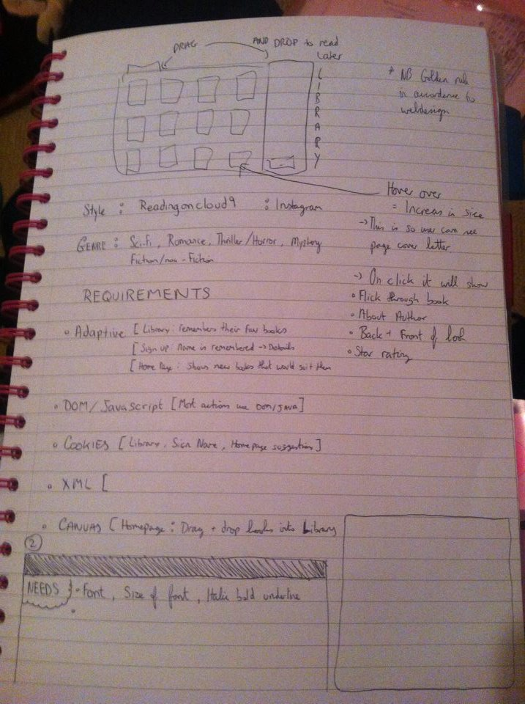

### Interaction:

I feel like **Marie the primary persona** would use this site on a regular basis and in the future earn a living

From writing the books on this server it would also be an interactive site were others would be able to leave

Comments so she can understand her readers more.

And **Patrick the secondary persona** would use this as a fun way to write stories and also read what his

Friends has created he would be able to follow some of his favourite authors (Like Marie) and also

Quite easily find the next book he would enjoy reading.

### Prototyping:

The first images are from before I 1) Saw any other of my classmates websites and 2) Let the users I

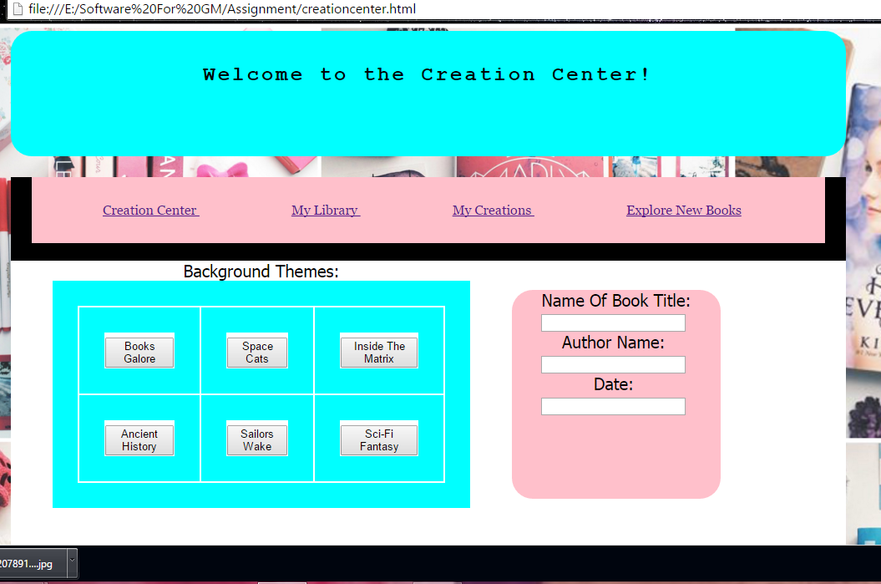

As you can see the overall look was quite childish and due to competition from other classmates (Because

They all looked so good) I was eager to change it.

The bottom of the screen looked as follows in the early stages:

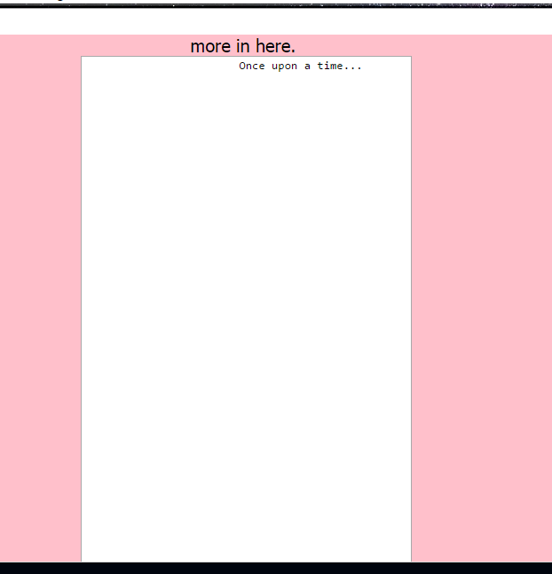

As you can see it is quite mundane and not exactly the look I was going for so I re-vamped

The whole thing until it looked more professional.

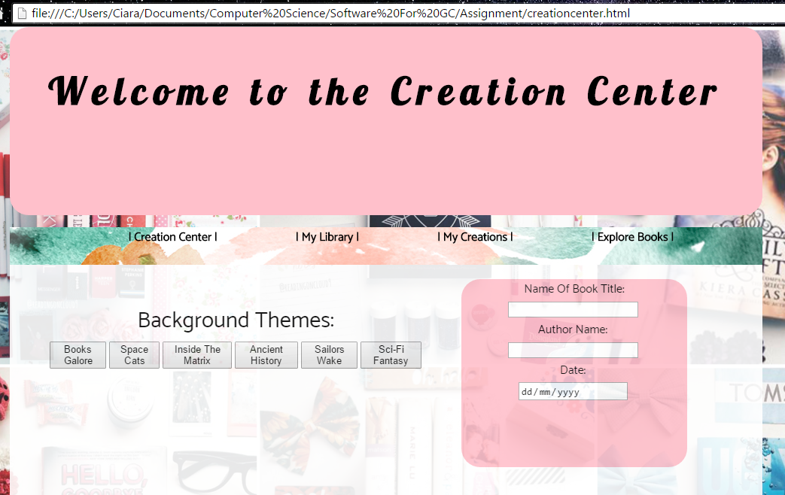

Once I was proud enough to show it off I just about threw it in front of everyone not just my

Personas, but to other people as I would consider this domain to be used by everyone.

### Changes through testing:

My mom while trying to navigate

Through the navigation bar **couldn’t see the text properly** so I used an increase size function so when

You hover over the text it increases in size not only does this help with readability it also give the site

More interaction with the user. Later on in the design process I also removed “My library” section

and added a “my Book Cover” section where the user can now create their very

own book cover with html canvas.

The themes where adapted to the personality of each of the users I had interviewed so it was

Fun to see how much they loved each different theme you could choose from.

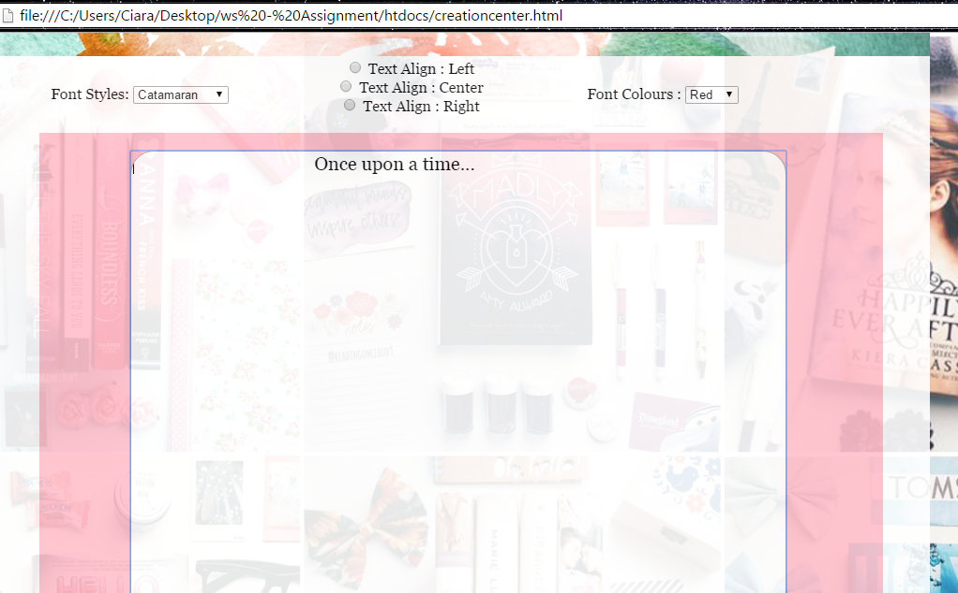

I also added more features so the “write your book” section which included **different styled fonts,**

**Different coloured fonts** and **text-alignment.**

When I showed it to my Uncle he suggested that I added smaller text underneath

The larger text in the header so it would look more professional.

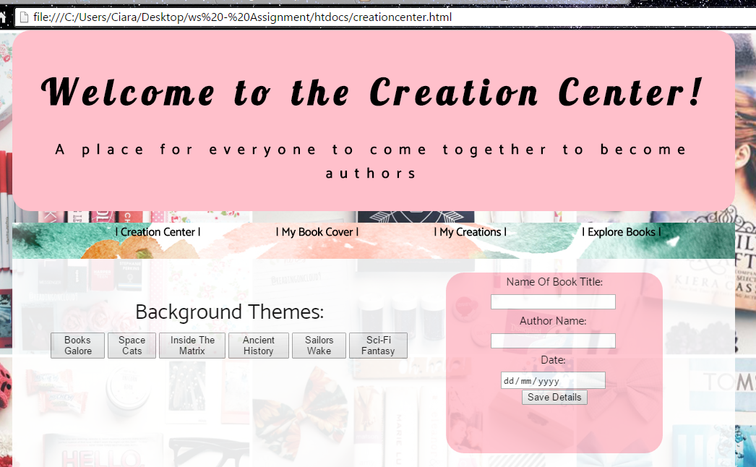

## Themes:

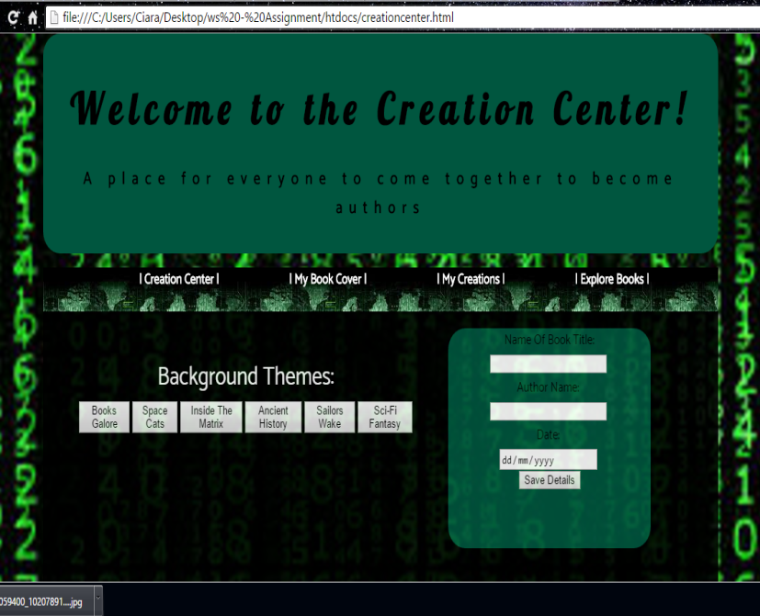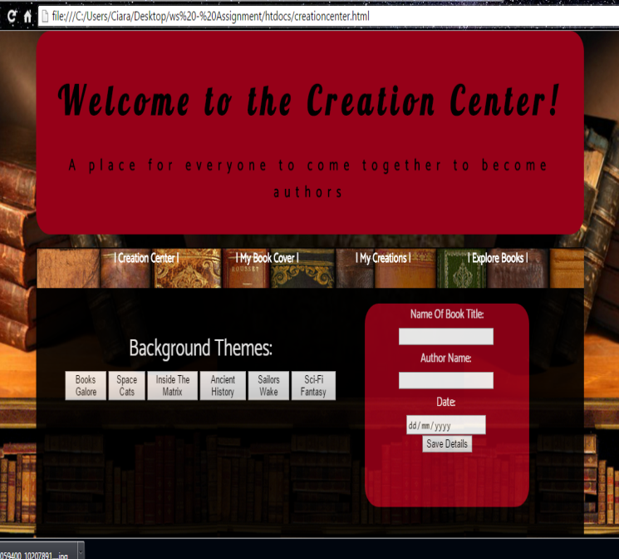

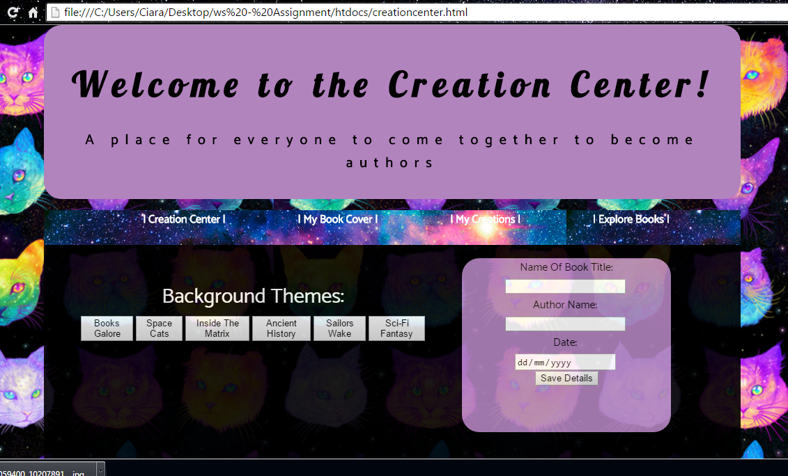

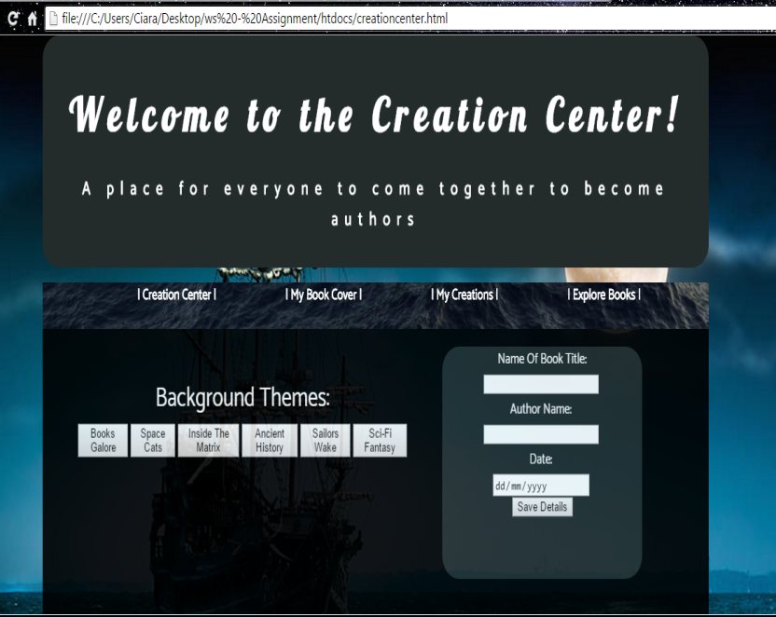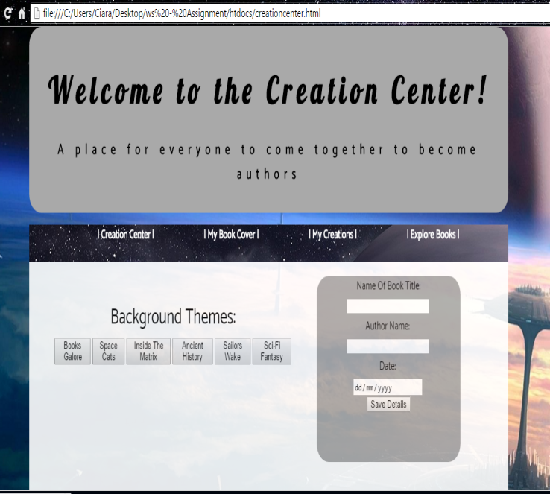

### Evaluation:

The over-all feedback I got was extremely useful and I felt like each user was more interested in the

Website due to its interactive properties. It was very handy to refer back to the personas as some had

Ideas for the website functionality and others had brilliant ideas for the look so the site which benefits the site

Because at the end of the day I am developing it for the user.

I also added in a **autofocus** feature which (once the page loads) it will outline the “Book Title” bar prompting

The user to enter in their details. This makes it easier for the user to understand what to do on the

Website without actual instructions.

Implementation

### Canvas:

The canvas I included was an **interactive canvas** where by the user can draw on the canvas and

Create their own book cover for their book. The reason for this was to make the book they have created

More personal to them.

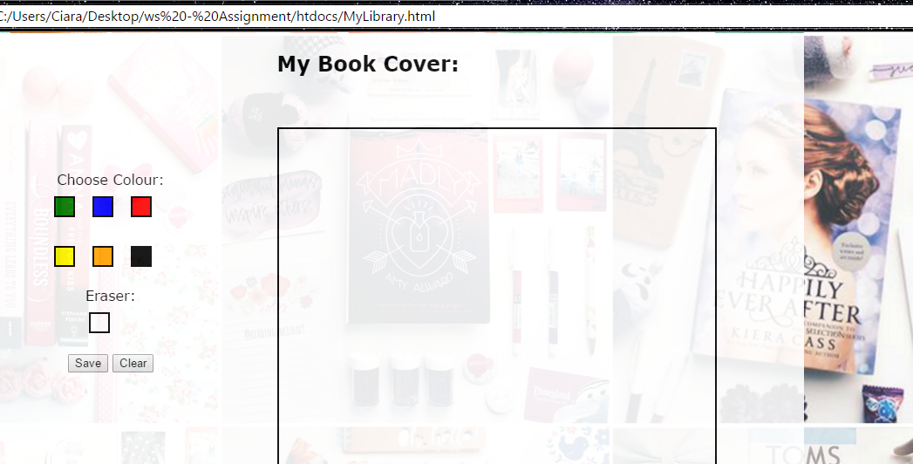

### Cookies:

The cookies I had were responsible for collecting the data that was stored once the user created their book,

And the cookie would bring it over and display it on the “My Creations” page so the user could view

Their work. The reason this is so important is because this is the main job of the domain.

### XML:

For this section I created a filing of the **top books** from fiction, action, horror, romance books and I brought

Them onto one page in the “Explore Books” page. This would help personas like Patrick who wish to

Find a book they would easily love based on their preferences.

### DOM/Javascript:

A lot of DOM and Javascript were used in order to create each and every one of the themes that you

Can switch to in the website. This is honestly my favourite function of them all because the themes are

All so different and it has the capability of suiting any user so the domain isn’t fixed to just one persona.

Conclusion

### My Thoughts:

I really enjoyed creating this website although I may have been very unrealistic with my vision vs. my skill

Set and what I can do I am very happy with the way that it turned out. I feel it is very important to

Always consider the user when making a site and for me the best way to include the “user” was to

Constantly show it off to friends and family whether it was on snap chat or in person. Everyone has

A great imagination and some people could possibly give you brilliant advice which would completely

Change your website layout of functionality for the better!

So always listen to the user!